# Report for Jordan Taylor (2024-10-01 to 2024-10-31)

Average Bat Speed: 46.63

Average Rotational Acceleration: 13.59

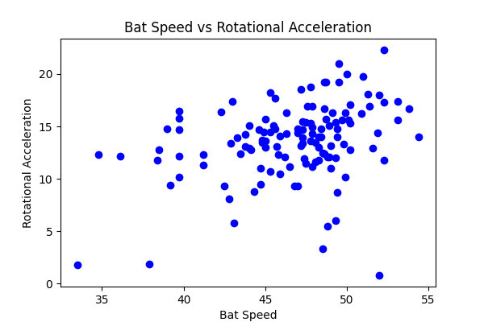

## Comments

Add comments here...